
P

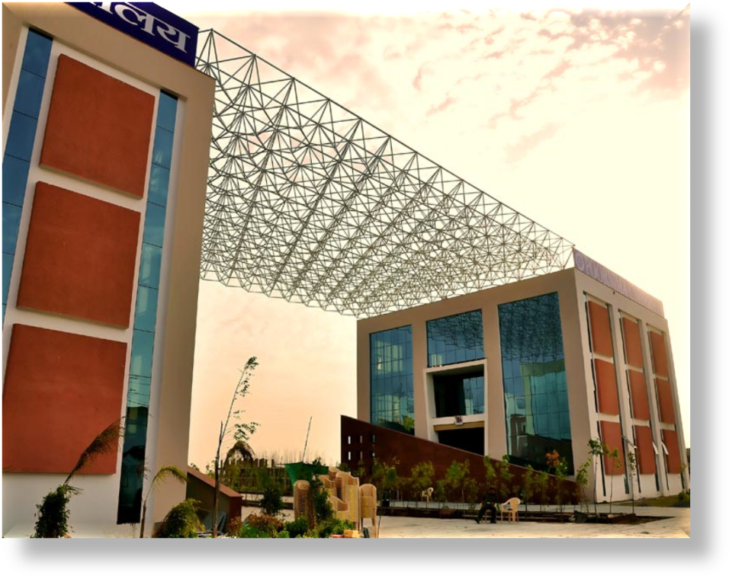

B.Tech Comp. Engg. (Cloud Technology and Information Security)

TEACHING SCHEMES

B.Tech Comp. Engg. (CT&IS) (Batch 2015-19)

POORNIMA UNIVERSITY
B.Tech CE (CT&IS) (Batch 2015-19)
First Year - First Semester
Subject Code | Subject Name | Teaching Scheme (Hrs per week) |  |  | Credits
Subject Code | Subject Name | Lec (L) | Tut (T) | Prac (P) | Credits
A. | Core Subjects (Theory)
BCC01101 | Technical English | 4 | - | - | 4
BCC01102 | Engineering Mathematics - I | 3 | - | - | 3
BCC01103 | Engineering Physics | 3 | - | - | 3
BCC01104 | Chemistry and Environmental Engineering | 3 | - | - | 3
BCC01105 | Computer Fundamentals and Organization | 4 | - | - | 4
BCC01106 | Programming in C | 4 | - | - | 4
B. | Departmental Electives (Theory) : ANY ONE
 | NIL
C. | Open Electives (Theory) – ANY ONE
 | NIL
D. | Practicals
BCC01207 | Programming in C Lab | - | - | 4 | 2
BCC01208 | Engineering Physics Lab | - | - | 2 | 1
BCC01209 | Engineering Chemistry Lab | - | - | 2 | 1
BCC01210 | Soft Skills, Effective Speaking and Analytical Skills - I |  |  | 4 | 2
E. | Special Programs/Project/Seminar
 | NIL | - | - | - | -
F. | Programmes / Activities
BCC01611 | Discipline and Talent Enrichment Programme (TEP) - I |  |  |  | 2
BCC01611.1 | Online Eligibility Exam (OLE) | 1 | - | - | -
BCC01611.2 | Programming Demonstrations | 1 | - | - | -
BCC01611.3 | Library | 1 | - | - | -
BCC01611.4 | Domain-level Tutorials | 1 | - | - | -
BCC01611.5 | Research and Presentations | 2 | - | - | -
 | Total | 27 | 0 | 12 | 29
 | Total Teaching Hours | 39 |  |  | 29

POORNIMA UNIVERSITY
B.Tech CE (CT&IS) (Batch 2015-19)
First Year - Second Semester
Subject Code |  | Subject Name | Teaching Scheme (Hrs per week) |  |  |  |  |  |  | Credits
 |  | Subject Name | Lec (L) |  |  | Tut (T) |  | Prac (P)
A. |  | Core Subjects (Theory)
BCC02101 |  | Communication Skills | 3 |  |  | - |  | - |  | 3
BCC02102 |  | Engineering Mathematics - II | 4 |  |  | - |  | - |  | 4
BCC02103 |  | OOPs with C++ | 4 |  |  | - |  | - |  | 4
BCC02104 |  | Introduction to Internet and Web Programming | 3 |  |  | - |  | - |  | 3
BCC02105 |  | Operating System Building Blocks | 5 |  |  | - |  | - |  | 5
BCC02106 |  | Information Security - I | 3 |  |  | - |  | - |  | 3
B. |  | Departmental Electives (Theory) : ANY ONE
 |  | NIL
C. |  | Open Electives (Theory) – ANY ONE
 |  | NIL
D. |  | Practicals
BCC02207 |  | OOPS with C++ Lab | - |  |  | - |  | 4 |  | 2
BCC02208 |  | Information Security Lab - I | - |  |  | - |  | 2 |  | 1
BCC02209 |  | Operating System Building Blocks Lab | - |  |  | - |  | 2 |  | 1
BCC02210 |  | Introduction to Internet and Web Programming Lab | - |  |  | - |  | 4 |  | 2
BCC02211 |  | Soft Skills, Effective Speaking and Analytical Skills - II |  |  |  |  |  | 2 |  | 1
E. |  | Project/Seminar
 |  | NIL | - |  |  | - |  | - |  | -
F. |  | Programmes / Activities
BCC02612 |  | Discipline and Talent Enrichment Programme (TEP) - II |  |  |  |  |  |  |  | 2
BCC02612.1 |  | Online Eligibility Exam (OLE) | 1 |  |  | - |  | - |  | -
BCC02612.2 |  | Programming Demonstrations | 1 |  |  | - |  | - |  | -
BCC02612.3 |  | Domain-level Tutorials | 1 |  |  | - |  | - |  | -
 |  | Total | 25 |  |  | - |  | 14 |  | 31
 |  | Total Teaching Hours | 39
POORNIMA UNIVERSITY
B.Tech CE (CT&IS) (Batch 2015-19)
Second Year - Third Semester
Subject Code |  | Subject Name |  | Teaching Scheme (Hrs per week) |  |  |  |  |  |  | Credits
 |  |  |  | Lec (L) |  |  | Tut (T) |  | Prac (P)
A. |  | Core Subjects (Theory)
BCC03101 |  | OSI Layer and Security |  | 4 |  |  | - |  | - |  | 4
BCC03102 |  | Network Security Basics |  | 4 |  |  | - |  | - |  | 4
BCC03103 |  | Data Structures and Algorithms |  | 3 |  |  | - |  | - |  | 3
BCC03104 |  | Computer Networks |  | 4 |  |  | - |  | - |  | 4
BCC03105 |  | Introduction to Linux |  | 3 |  |  | - |  | - |  | 3
B. |  | Departmental Electives (Theory) : ANY ONE
 |  | -
C. |  | Open Electives (Theory) – ANY ONE
BOE03121 |  | Industrial Psychology and Sociology |  | 3 |  |  | - |  | - |  | 3
BOE03122 |  | Nano Science and Technology
BOE03123 |  | Data Structure*
BOE03124 |  | Object Oriented Programming using C++ *
BOE03125 |  | Non-Conventional Energy Sources
BOE03126 |  | French Language
BOE03127 |  | Basics of Engineering Applications
D. |  | Practicals
BCC03206 |  | Computer Networks Lab |  | - |  |  | - |  | 4 |  | 2
BCC03207 |  | Network Security Lab |  | - |  |  | - |  | 2 |  | 1
BCC03208 |  | Introduction to Linux Lab |  | - |  |  | - |  | 2 |  | 1
BCC03209 |  | Data Structures and Algorithms Lab |  | _ |  |  | _ |  | 4 |  | 2
E. |  | Project/Seminar
BCC03310 |  | Personal Effectiveness Skills |  | - |  |  | - |  | 2 |  | 1
F. |  | Programmes / Activities
BCC03611 |  | Discipline and Talent Enrichment Programme (TEP) - III |  |  |  |  |  |  |  |  | 2
BCC03611.1 |  | Online Eligibility Exam (OLE) |  | 1 |  |  | - |  | - |  | -
BCC03611.2 |  | Programming Demonstrations |  | 1 |  |  | - |  | - |  | -
BCC03611.3 |  | Domain-level Tutorials |  | 1 |  |  | - |  | - |  | -
BCC03611.4 |  | Library |  | 1 |  |  | - |  | - |  | -
 |  | Total |  | 25 |  |  | - |  | 14 |  | 30
 |  | Total Teaching Hours |  | 39
*Not offered to Computer Engineering students
POORNIMA UNIVERSITY
B.Tech CE (CT&IS) (Batch 2015-19)
Second Year - Fourth Semester
Subject Code |  | Subject Name |  | Teaching Scheme (Hrs per week) |  |  |  |  |  |  | Credits
 |  |  |  | Lec |  |  | Tut |  | Prac
A. |  | Core Subjects (Theory)
BCC04101 |  | Introduction to Cloud Technology |  | 4 |  |  | - |  | - |  | 4
BCC04102 |  | Engineering Mathematics - III |  | 3 |  |  | - |  | - |  | 3
BCC04103 |  | Desktop Operating Systems |  | 3 |  |  | - |  | - |  | 3
BCC04104 |  | Server Operating System – I |  | 4 |  |  | - |  | - |  | 4
BCC04105 |  | Ethical Hacking Fundamentals |  | 4 |  |  | - |  | - |  | 4
B. |  | Departmental Electives (Theory) : ANY ONE
BCC04106 |  | Information Security – II |  | 3 |  |  | - |  | - |  | 3
BCC04107 |  | Security Threats and Trends
C. |  | Open Electives (Theory) : ANY ONE
 |  | NIL
D. |  | Practicals
BCC04208 |  | Desktop Operating Systems Lab |  | - |  |  | - |  | 2 |  | 1
BCC04209 |  | Server Operating System Lab - I |  | - |  |  | - |  | 2 |  | 1
BCC04210 |  | Ethical Hacking Fundamentals Lab |  | - |  |  | - |  | 4 |  | 2
E. |  | Project/Seminar
BCC04311 |  | Effective Communication |  | - |  |  | - |  | 4 |  | 2
BCC04312 |  | Mini Project - I |  | - |  |  | - |  | 2 |  | 1
F. |  | Programmes / Activities
BCC04613 |  | Discipline and Talent Enrichment Programme (TEP) - IV |  |  |  |  |  |  |  |  | 2
BCC04613.1 |  | Online Eligibility Exam (OLE) |  | 1 |  |  | - |  | - |  | -
BCC04613.2 |  | Research and Presentation |  | 1 |  |  | - |  | - |  | -
BCC04613.3 |  | Programming Demonstrations |  | 1 |  |  | - |  | - |  | -
BCC04613.4 |  | Extra Curricular Activities - Events |  | 1 |  |  | - |  | - |  | -
 |  | Total |  | 25 |  |  | - |  | 14 |  | 30
 |  | Total Teaching Hours |  | 39
POORNIMA UNIVERSITY
B.Tech CE (CT&IS) (Batch 2015-19)
Third Year - Fifth Semester
Subject Code |  | Subject Name |  | Teaching Scheme (Hrs per week) |  |  |  |  |  |  | Credits
 |  |  |  | Lec |  |  | Tut |  | Prac
A. |  | Core Subjects (Theory)
BCC05101 |  | Principles of Virtualization |  | 4 |  |  | - |  | - |  | 4
BCC05102 |  | Fundamentals of Datacenter |  | 4 |  |  | - |  | - |  | 4
BCC05103 |  | Cryptography Fundamentals |  | 3 |  |  | - |  | - |  | 3
BCC05104 |  | Fundamentals of Storage |  | 4 |  |  | - |  | - |  | 4
BCC05105 |  | Basic Scripting Languages |  | 3 |  |  | - |  | - |  | 3
B. |  | Departmental Electives (Theory) : ANY ONE
 |  | NIL
C. |  | Open Elective (Theory) : ANY ONE
BOE05128 |  | Essentials of Management |  | 4 |  |  | - |  | - |  | 4
BOE05129 |  | Essentials of Information Technology*
BOE05130 |  | Organizational Behavior and Cyber Law
BOE05131 |  | Project Management
BOE05132 |  | Human Values and Professional Ethics
BOE05133 |  | Introduction to Soft Computing
D. |  | Practicals
BCC05206 |  | Principles of Virtualization Lab |  | - |  |  | - |  | 4 |  | 2
BCC05207 |  | Basic Scripting Languages Lab |  | - |  |  | - |  | 4 |  | 2
E. |  | Project/Seminar
BCC05308 |  | Life and Career Skills |  | - |  |  | - |  | 2 |  | 1
BCC05309 |  | Industrial Training Seminar (ITS) |  | - |  |  | - |  | 1 |  | 0.5
F. |  | Programmes / Activities
BCC05610 |  | Discipline and Talent Enrichment Programme (TEP) - V |  |  |  |  |  |  |  |  | 2
BCC05610.1 |  | Online Eligibility Exam (OLE) |  | 1 |  |  | - |  | - |  | -
BCC05610.2 |  | Research and Presentation |  | 1 |  |  | - |  | - |  | -
BCC05610.3 |  | Programming Demonstrations |  | 1 |  |  | - |  | - |  | -
BCC05610.4 |  | Extra Curricular Activities - Events |  | 1 |  |  | - |  | - |  | -
 |  | Total |  | 26 |  |  | - |  | 11 |  | 29.5
 |  | Total Teaching Hours |  | 37
Professional Certificate Course (PCC) shall be offered to all students equivalent to 2hrs/wk. This course is Non credit Certificate course and therefore is not a part of mark sheet / grade sheet. *Not offered to Computer Engineering students
POORNIMA UNIVERSITY
B.Tech CE (CT&IS) (Batch 2015-19)
Third Year - Sixth Semester
Subject Code | Subject Name |  |  | Teaching Scheme (Hrs per week) |  |  |  |  |  |  | Credits
Subject Code |  |  |  | Lec |  |  | Tut |  | Prac
A. | Core Subjects (Theory)
BCC06101 | Introduction to Cloud Computing Solutions |  |  | 4 |  |  | - |  | - |  | 4
BCC06102 | Server Operating System – II |  |  | 3 |  |  | - |  | - |  | 3
BCC06103 | IT Governance, Risk and Information Security Management |  |  | 3 |  |  | - |  | - |  | 3
BCC06104 | Cyber Forensics – An Introduction |  |  | 4 |  |  | - |  | - |  | 4
BCC06105 | Fundamentals of Exchange Server |  |  | 4 |  |  | - |  | - |  | 4
B. | Departmental Electives (Theory) : ANY ONE
BCC06106 | Disaster Recovery and Business Continuity |  |  | 3 |  |  | - |  | - |  | 3
BCC06107 | OWASP Framework
C. | Open Elective (Theory) : ANY ONE
 | NIL
D. | Practicals
BCC06208 | Introduction to Cloud Computing Solutions Lab |  |  | - |  |  | - |  | 4 |  | 2
BCC06209 | Server Operating System Lab - II |  |  | - |  |  | - |  | 2 |  | 1
BCC06210 | Cyber Forensics – An Introduction Lab |  |  | - |  |  | - |  | 2 |  | 1
E. | Project/Seminar
BCC06311 | Mini Project - II |  |  | - |  |  | - |  | 2 |  | 1
F. | Programmes / Activities
BCC06612 | Discipline and Talent Enrichment Programme (TEP) - VI |  |  |  |  |  |  |  |  |  | 2
BCC06612.1 | Online Eligibility Exam (OLE) |  |  | 1 |  |  | - |  | - |  | -
BCC06612.2 | Campus Recruitment Training - Aptitude |  |  | 2 |  |  | - |  | - |  | -
BCC06612.3 | Programming Demonstrations |  |  | 1 |  |  | - |  | - |  | -
BCC06612.4 | Domain-level Tutorials |  |  | 1 |  |  | - |  | - |  | -
 | Total |  |  | 26 |  |  | - |  | 10 |  | 28
 | Total Teaching Hours |  |  | 36
Professional Certificate Course (PCC) shall be offered to all students equivalent to 3hrs/wk. This course is Non credit Certificate course and therefore is not a part of mark sheet / grade sheet.
POORNIMA UNIVERSITY
B.Tech CE (CT&IS) (Batch 2015-19)
Fourth Year - Seventh Semester
Subject Code |  | Subject Name |  | Teaching Scheme (Hrs per week) |  |  |  |  |  |  | Credits
 |  |  |  | Lec |  |  | Tut |  | Prac
A. |  | Core Subjects (Theory)
BCC07101 |  | Server Operating System – I – Advanced |  | 4 |  |  | - |  | - |  | 4
BCC07102 |  | Virtualization and Cloud Security |  | 4 |  |  | - |  | - |  | 4
BCC07103 |  | Security in Wireless, VoIP and Mobile Apps |  | 4 |  |  | - |  | - |  | 4
BCC07104 |  | Android Security |  | 4 |  |  | - |  | - |  | 4
B. |  | Departmental Electives (Theory): ANY ONE
BCC07105 |  | Hacktivism, Cyber Warfare and Cyber Terrorism |  | 4 |  |  | - |  | - |  | 4
BCC07106 |  | Linux Security and Forensics
C. |  | Open Electives (Theory) : ANY ONE
BOE07134 |  | Entrepreneurship
BOE07135 |  | IPR and Patents
BOE07136 |  | E-Commerce |  | 3 |  |  | - |  | - |  | 3
BOE07137 |  | Total Quality Management
BOE07138 |  | Logistics and Supply Chain Management
BOE07139 |  | Basics of Petro Industry
D. |  | Practicals
BCC07207 |  | Server Operating System – I – Advanced Lab |  | - |  |  | - |  | 4 |  | 2
BCC07208 |  | Android Security Lab |  | - |  |  | - |  | 2 |  | 1
E. |  | Project/Seminar
BCC07309 |  | Transition from Campus to Corporate |  | - |  |  | - |  | 2 |  | 1
BCC07310 |  | Technical Seminar |  | - |  |  | - |  | 2 |  | 1
F. |  | Programmes / Activities
BCC07611 |  | Discipline and Talent Enrichment Programme (TEP) - VII |  |  |  |  |  |  |  |  | 2
BCC07611.1 |  | Online Eligibility Exam (OLE) |  | 1 |  |  | - |  | - |  | -
BCC07611.2 |  | Campus Recruitment Training |  | 2 |  |  | - |  | - |  | -
BCC07611.3 |  | Programming Demonstrations |  | 2 |  |  | - |  | - |  | -
BCC07611.4 |  | Domain-level Tutorial |  | 1 |  |  | - |  | - |  | -
 |  | Total |  | 29 |  |  | - |  | 10 |  | 30
 |  | Total Teaching Hours |  | 39
POORNIMA UNIVERSITY
B.Tech CE (CT&IS) (Batch 2015-19)
Fourth Year - Eighth Semester
Subject Code |  | Subject Name |  | Teaching Scheme (Hrs per week) |  |  |  |  |  |  | Credits
 |  |  |  | Lec |  |  | Tut |  | Prac
A. |  | Core Subjects (Theory)
BCC08101 |  | Business Organization Basics |  | 4 |  |  | - |  | - |  | 4
B. |  | Departmental Electives (Theory): ANY ONE
BCC08102 |  | Fundamentals of IT Infrastructure Library |  | 4 |  |  | - |  | - |  | 4
BCC08103 |  | Introduction to VoIP
C. |  | Open Electives (Theory) : ANY ONE
 |  | NIL
D. |  | Practicals
 |  | NIL
E. |  | Project/Seminar
BCC08304 |  | Major Project/Internship |  | - |  |  | - |  | 20 |  | 10
F. |  | Programmes / Activities
BCC08605 |  | Discipline and Talent Enrichment Programme (TEP) - VIII |  |  |  |  |  |  |  |  | 2
BCC08605.1 |  | Online Eligibility Exam (OLE) |  | 1 |  |  | - |  | - |  | -
BCC08605.2 |  | Campus Recruitment Training |  | 3 |  |  | - |  | - |  | -
BCC08605.3 |  | Programming Demonstrations |  | 1 |  |  | - |  | - |  | -
BCC08605.4 |  | Domain-level Tutorial |  | 1 |  |  | - |  | - |  | -
BCC08605.5 |  | Library |  | 1 |  |  | - |  | - |  | -
 |  | Total |  | 15 |  |  | - |  | 20 |  | 20
 |  | Total Teaching Hours |  | 35
Professional Certificate Course (PCC) shall be offered to all students equivalent to 4hrs/wk. This course is Non credit Certificate course and therefore is not a part of mark sheet / grade sheet.

********

